Wholesale sock form

The minimum amount for a dress sock order is 10 pairs with a maximum of thirty. At the minimum amount, customers receive the wholesale price of $10.00 per pair. Unless specified, the standard dress sock has a twenty-stitch ribbing at the commencement end of the sock, and a 50 stitch ankle. Customers must specify sizes upon ordering in the form below. Dress socks come in large, which fits a size 11-10 and medium, which fits a size 9-7 comfortably.

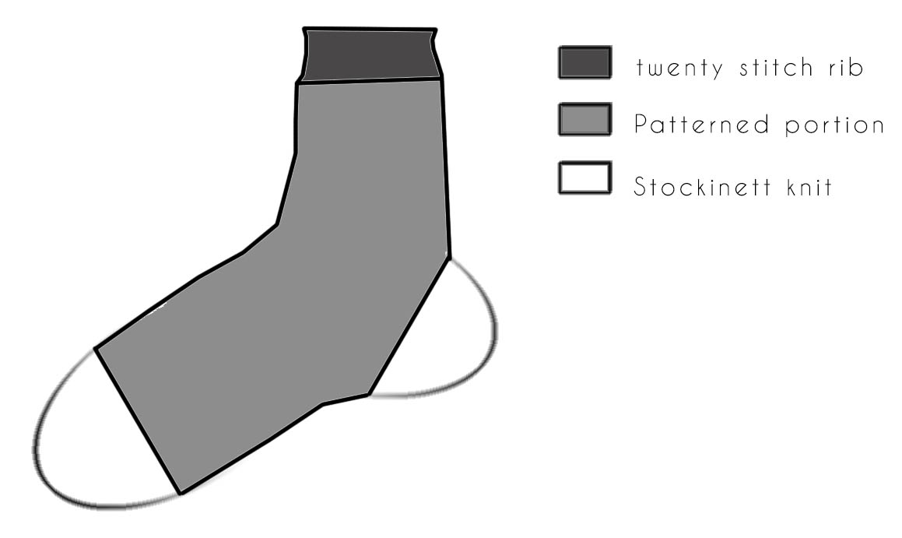
In the graphic to the left, the portions of the sock are shown in plain detail. The twenty stitch ribbing at the top, the customizable patterned portion, and the mandatory stockinet knitting at the heel and toe of the sock.

Customization
For the customizable portion, one can choose from the options provided in the extra piece attached to this form. Patterns may come as a textured “tucked” stitch or an 8bit color pattern. Color graphics may be customized per the request of the customer, but must be approved, as there are limitations to our machines ability to knit complicated patterns.

Customer Name _______________________________________________

Shipping address_____________________________________ City _____________

State _________________ Postal code ___________________

Ribbing ___________________________ (If not specified, it comes twenty row standard).

Customized Pattern _________________________

Pairs (the number of pairs ordering) _____________________

Pattern chart

Wave scale
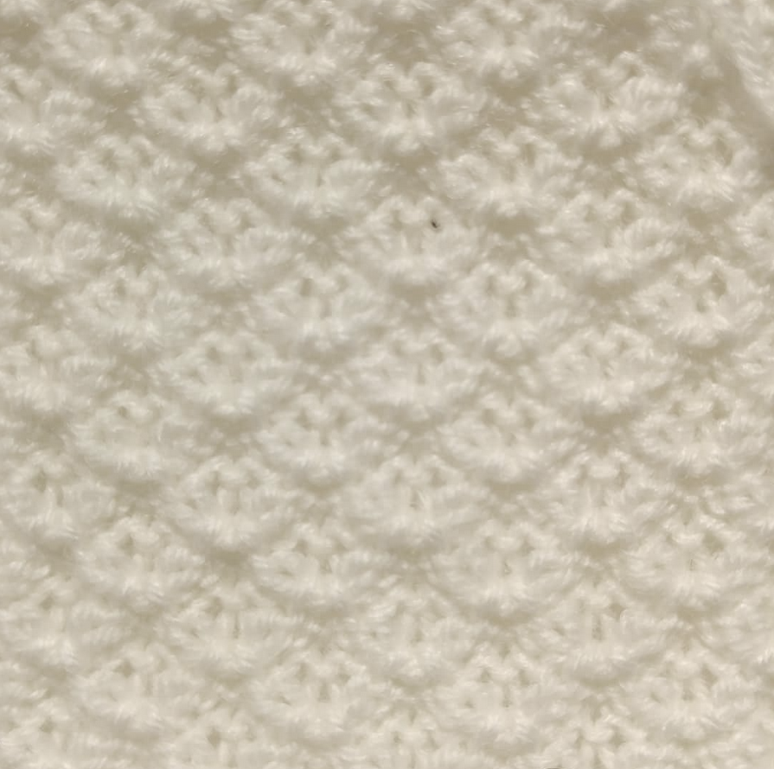
Honey Comb
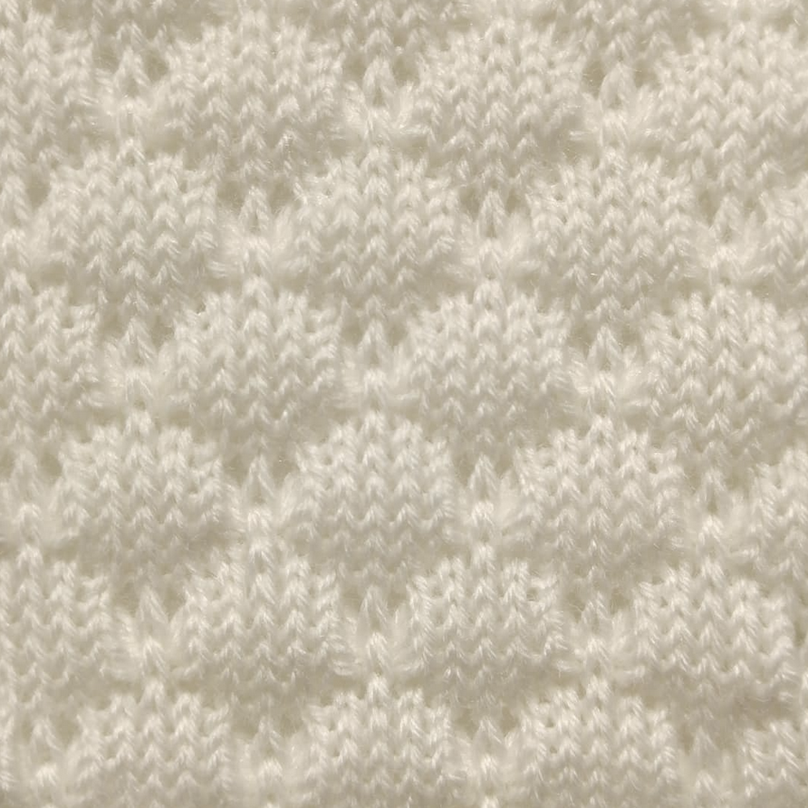
Quilted
Tight Tuck

